# Crest-100x131pix

**Semester One Examination 2011**

**Question/Answer Booklet**

**MATHEMATICS SPECIALIST**

**MAS 3C/D**

**Section One**

**(Calculator Free)**

Student name

## Time allowed for this section

Reading time before commencing work: 5 minutes

Working time for paper: 50 minutes

## Material required/recommended for this section

##### To be provided by the supervisor

Question/answer booklet for Section One.

Formula sheet.

##### To be provided by the candidate

Standard items: pens, pencils, pencil sharpener, highlighter, eraser, ruler.

**Important note to candidates**

No other items may be taken into the examination room. It is your responsibility to ensure that you do not have any unauthorised notes or other items of a non-personal nature in the examination room. If you have any unauthorised material with you, hand it to the supervisor before reading any further.

## Structure of this examination

|  |  |  |  |
| --- | --- | --- | --- |
|  | Number of questions | Working time (minutes) | Marks available |
| **This Section (Section 1)**  **Calculator Free** | **8** | **50** | **40** |
| Section Two  Calculator Assumed | 13 | 100 | 80 |
| Total marks | | | 120 |

## Instructions to candidates

1. The rules for the conduct of WACE external examinations are detailed in the booklet *WACE Examinations Handbook*. Sitting this examination implies that you agree to abide by these rules.
2. Answer the questions in the spaces provided.
3. Show all working clearly. Any question, or part question, worth more than 2 marks requires valid working or justification to receive full marks. If you repeat an answer to any question, ensure that you cancel the answer you do not wish to have marked.

1. [4 marks]

Let z = 5 - i

(a) Find z2 in the form *x + iy.* [1]

(b) Find z + 2 $\overline{z}$ in the form *x + iy*. [1]

(c) Find $\frac{i}{z}$ in the form *x + iy*. [2]

2. [2 marks]

On the Argand diagram below, shade the region given by

}

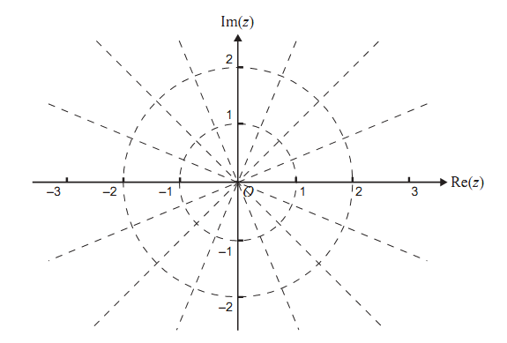

3. [3 marks]

Solve the following equation for x ϵ **R**, giving an exact answer(s) for x.

4. [9 marks]

Find $\frac{dy}{dx}$ for the following

.

1. $y= (e^{x} . x^{0.5})$ [1]

(b)  [2]

(c)  [2]

(d) ,  Give your answer in terms of *t*. [2]

(e) For question (d) above find  Give your answer in terms of *t*. [2]

5. [6 marks]

If z = 3 cis ($\frac{π}{4}$) and w = 2 cis ($\frac{π}{3}$)

Express the following in polar form.

(a) $\frac{z}{w}$ [1]

(b) z w [1]

(c) $\overline{z}$ [1]

(d) i*w* [1]

(e) *w*3 [1]

(f)  [1]

6. [4 marks]

Determine the following integrals:

(a) [2]

(b)  [2]

7. [5 marks]

Let z = cos θ + i sin θ where  .

On the Argand diagram the point A represents z, the point B represents z2 and the point C represents z + z2.

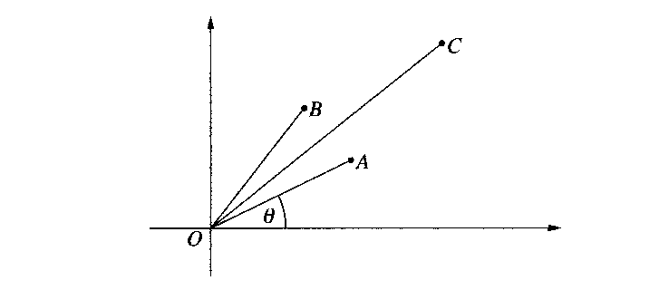

(a) Explain why the paralleogram OACB is a rhombus. [1]

(b) Show that  . [1]

(c) Show that  . [2]

(d) Using  , deduce that  [1]

8. [7 marks]

(a) Find the derivative of  and hence or otherwise determine  [2]

(b) Evaluate exactly  using the substitution  [5]

**End of Questions**



**Semester One Examination 2011**

**Question/answer booklet**

**MATHEMATICS SPECIALIST**

**MAS 3C/D**

**Section Two**

**(Calculator Assumed)**

|  |
| --- |
| Student Name: _____________________________________________ |

**Time allowed for this section**

Reading time before commencing work: 10 minutes

Working time for section: 100 minutes

**Material required/recommended for this section**

**To be provided by the supervisor**

Question/answer booklet for Section Two. Candidates may use the removable formula sheet from Section One

**To be provided by the candidate**

Standard items: pens, pencils, pencil sharpener, highlighter, eraser, ruler

Special items: drawing instruments, templates, notes on up to two unfolded sheets of A4 paper, and up to three calculators, CAS, graphic or scientific, which satisfy the conditions set by the Curriculum Council for this course.

## Important note to candidates

No other items may be taken into the examination room. It is your responsibility to ensure that you do not have any unauthorised notes or other items of a non-personal nature in the examination room. If you have any unauthorised material with you, hand it to the supervisor before reading any further.

## Structure of this examination

|  |  |  |  |
| --- | --- | --- | --- |
|  | Number of questions | Working time (minutes) | Marks available |
| Section One  Calculator Free | 8 | 50 | 40 |
| **This Section (Section 2)**  **Calculator Assumed** | **13** | **100** | **80** |
| Total marks | | | 120 |

## Instructions to candidates

1. The rules for the conduct of WACE external examinations are detailed in the booklet *WACE Examinations Handbook*. Sitting this examination implies that you agree to abide by these rules.
2. Answer the questions in the spaces provided.
3. Show all working clearly. Any question, or part question, worth more than 2 marks requires valid working or justification to receive full marks. If you repeat an answer to any question, ensure that you cancel the answer you do not wish to have marked.

1. [3 marks]

Let z1 = *cis* ().

(a) Plot and label carefully the points *z*1, -*z*1, 1 and -1 on the Argand diagram below. [2]



(b) Write down the complex equation (in terms of 1 and -1) of the straight line which passes through the points *z*1 and -*z*1. [1]

2. [9 marks]

*z* - axis

*y* - axis

*x* - axis

A(0, 0, 4)

H(2, 0, 0)

F(0, 5, 0)

D

E(0, 0, 0)

B

C

G

(a) Find the equation of the line parallel to **AG** through the point A. [2]

(b) Find the angle between **GB** and **GF** using vector methods. [3]

(c) Using point A, **AB** and **AD**, write the equation of the plane ABCD. [3]

(d) Can the equation of plane ABCD be created using **AB** and **DC**? Explain. [1]

3. [4 marks]

Find the shortest distance between the line  and the

point (2, -1, 2).

4. [4 marks]

OAB is a triangle with **OA** = 3**i** + 2**j+ $\sqrt{3}$**  **k** and **OB** = α **i** where  , which is greater than zero, is chosen so that triangle OAB is isosceles, with $\left|OA\right|$ = $\left|OB\right|$.

(a) Show that  . [1]

(b) Find **OQ** , where Q is the midpoint of the line segment AB. [1]

(c) Use a vector method to show that **OQ** is perpendicular to **AB**. [2]

5. [7 marks]

The points A and B are given in polar co-ordinates.

1. Find the distance between the two points. [2]
2. Find two different spirals that contain point A. [2]
3. Find the equation in Polar form and Cartesian form of the **ray** that starts at the origin and contains the point B. [3]

6. [12 marks]

An aircraft approaching an airport with velocity  metres per second is observed on the control tower radar screen at time t = 0 seconds. Ten seconds later it passes over a navigation beacon with position vector (–500**i** + 2500**j**) metres relative to the base of the control tower, at an altitude of 200 metres.

(a) Show that the position vector of the aircraft relative to the base of the control tower at time t is given by

**r**(t) = (30t – 800) **i** + (2900 – 40t) **j** + (240 – 4t) **k** [3]

(b) When does the aircraft land and how far (correct to the nearest metre) from the base of the control tower is the point of landing? [3]

(c) At what angle from the runway, correct to the nearest tenth of a degree, does the aircraft land? [2]

(d) At what time, correct to the nearest second, is the aircraft closest to the base of the control tower? [2]

(e) What distance does the aircraft travel from the time it is observed on the radar screen to the time it lands? Give your answer correct to the nearest metre? [2]

7. [4 marks]

The diagram below shows a sketch of two curves *f*(*x*) and *g*(*x*).

*f*(*x*)

*g*(*x*)

*a*

*b*

*c*

*d*

*e*

1. In terms of *f*(*x*), *g*(*x*), *a*, *b*, *c*, *d* and *e* write an expression that can be used to find the value of the area shade. [2]
2. Given that  and  find the value of the shaded area. [2]

8. [7 marks]

Find the equations of *two* of the tangents to the curve  that have a gradient of . Give your answers exactly in terms of *k*.

9. [6 marks]

The total number of bacteria found on a bench top after bleach has been applied can be approximately modelled by the differential equation 

where *B* is the number of bacteria and *t* is the time measured in seconds.

Three seconds after the bleach was applied it was found that there were 104 000 bacteria still alive on the bench top.

(a) Find *B* in terms of *t*. [4]

(b) What was the number of bacteria initially on the bench top? Give your answer to the nearest 1000 bacteria. [1]

1. After a long time how many bacteria survived the bleaching process? [1]

10. [7 marks]

A plane travelling at 720 km/hr at a constant height of 500 metres above ground level is being tracked by radar. The distance along the ground is *x* and the angle of elevation to the plane is θ, as per the diagram below. At a time *t = 0* seconds the plane is directly overhead.



720 km/hr

500 metres

C:\Users\belr\AppData\Local\Microsoft\Windows\Temporary Internet Files\Content.IE5\OIHYFV0L\MC900413602[1].wmf θ

*x*

1. Find $\frac{dθ}{dt}$ as a function of θ. [5]

(b) Calculate $\frac{dθ}{dt}$ 5 seconds after being overhead. [2]

11. [10 marks]

OQ, AR are respectively the medians of Δ OAB B

(Q and R are the midpoints of AB and OB).

Let the medians intersect at M. Also, let

**OA** = **a**, **OB** = **b**, **OM** = α **OQ** and **AM** = β **AR**. R Q

M

O P A

1. Find **OQ** and **AR** in terms of **a** and/or **b**. [2]
2. Hence, find **OM** and **AM** in terms of **a** and/or **b**. [1]
3. Prove that α = β = $\frac{2}{3}$ [3]
4. Find **BM** and **MP** in terms **a** and/or **b**. [2]
5. Hence, prove that B, M and P are collinear. [1]
6. Hence, what can you conclude about the medians of a triangle. [1]

12. [4 marks]

Use mathematical induction to prove the following identity true for integers *n* ≥ 1.

$\frac{d^{2n}}{{dx}^{2n}}$ (*sin* *x*) = (– 1)*n* *sin* *x*

13. [3 marks]

Show that the solution *y* = *sin x* makes the following differential identity true for all *x*.

(*y*2 *sec* 2 *x* + 1) [*sin* 2*x* + 2 + ( )2 ] = 1 for *sec* *x* =

**End of Questions**